**Mini Project 1 A Report**

Submitted in partial fulfillment of the requirement of University of Mumbai

For the Degree of

**(Computer Engineering)**

**By**

**1) “Yash Phuke” “ID No: TU3F2122117”**

**2) “Kiran Mishra” “ID No: TU3F2122105”**

**Under the Guidance of**

**Prof. Vishwajit Gaiwad**



**Department of Computer Engineering**

**TERNA ENGINEERING COLLEGE**

**Plot no.12, Sector-22, Opp. Nerul Railway station,**

**Phase-11, Nerul (w), Navi Mumbai 400706**

**UNIVERSITY OF MUMBAI**



**TERNA ENGINEERING COLLEGE, NERUL,**

**NAVI MUMBAI**

**Department of Computer Engineering**

Academic Year 2022-23

**CERTIFICATE**

This is to certify that the mini project 2 A entitles “Mini Project Title” is a bonafide work of

1. **“Yash Phuke” “ID No: TU3F2122117”**

**2) “Kiran Mishra” “ID No: TU3F2122105”**

submitted to the University of Mumbai in partial fulfillment of the requirement for the award of the Bachelor of Engineering (Computer Engineering).

**Guide Head of Department Principal**

**Project Report Approval**

This Mini Project 2A Report – entitled “**Mini Project Title**” by following students is approved for the degree of ***T.E. in "Computer Engineering"***.

**Submitted by:**

1. **“Yash Phuke” “ID No: TU3F2122117”**

**2) “Kiran Mishra” “ID No: TU3F2122105”**

Examiners Name & Signature:

1.---------------------------------------------------------

2.----------------------------------------------------------

Date: ---------------------------------

Place: ---------------------------------

**Declaration**

We declare that this written submission represents our ideas in our own words and where others' ideas or words have been included, we have adequately cited and referenced the original sources. We also declare that we have adhered to all principles of academic honesty and integrity and have not misrepresented or fabricated or falsified any idea/data/fact/source in our submission. We understand that any violation of the above will be cause for disciplinary action by the Institute and can also evoke penal action from the sources which have thus not been properly cited or from whom proper permission has not been taken when needed.

1. **“Yash Phuke” “ID No: TU3F2122117”**

**2) “Kiran Mishra” “ID No: TU3F2122105”**

Date: _____________________

Place: _____________________

**Acknowledgement**

We would like to express our sincere gratitude towards our guide **Prof. Guide name**, Mini Project Coordinators **Prof. Mini Project Coordinator** for their help, guidance and encouragement, they provided during the project development. This work would have not been possible without their valuable time, patience and motivation. We thank them for making our stint thoroughly pleasant and enriching. It was great learning and an honor being their student.

We are deeply thankful to **Dr. Seema Bidey (H.O.D Computer Department)** and entire team in the Computer Department. They supported us with scientific guidance, advice and encouragement, they were always helpful and enthusiastic and this inspired us in our work.

We take the privilege to express our sincere thanks to **Dr. L. K. Ragha**our Principal for providing the encouragement and much support throughout our work.

1. **“Yash Phuke” “ID No: TU3F2122117”**

**2) “Kiran Mishra” “ID No: TU3F2122105”**

Date: _____________________

Place: _____________________

**Index**

|  |  |  |
| --- | --- | --- |
| **TABLE OF CONTENTS** | | |
| **Sr. No.** | **Title** | **Page No.** |
|  | **Abstract** |  |
|  | **List of Figures** |  |
|  | **List of Tables** |  |
| Chapter 1 | Introduction   * 1. Sub chapter   2. Sub chapter |  |
| Chapter 2 | Problem Statement |  |
| Chapter 3 | Literature Survey |  |
| Chapter 4 | Design and Implementation |  |
| Chapter 5 | Results |  |
| Chapter 6 | Conclusion and future work |  |
|  | Reference |  |

## Abstract

* **The face detection & Attendance marking system is a computer vision project that utilizes OpenCV, Firebase, and facial recognition algorithms. The objective of this project is to create an automated attendance system that can capture an image or video stream, detect faces using OpenCV, match the detected faces with the faces stored in Firebase's real-time database, and finally, mark attendance for recognized faces.**
* **This project has various potential applications in the education and corporate sector, where attendance management is a critical task. The automated attendance marking system can help reduce the time and effort required for manual attendance marking, improve accuracy, and provide real-time insights into attendance patterns.**

|  |  |  |
| --- | --- | --- |
|  |  |  |
|  |  |  |
|  |  |  |
|  |  |  |
|  |  |  |
|  |  |  |

**List of Tables**

|  |  |  |
| --- | --- | --- |
| **Sr.no** | **Name** | **Pg.no** |
| **1)** | **Introduction** | **9** |
| **2)** | **Problem Statement** | **10** |
| **3)** | **Literature Review** | **11** |
| **4)** | **Design and Implementation** | **12** |
| **5)** | **Results and Discussions** | **13** |
| **6)** | **Conclusion and Future Scope** | **17** |
| **7)** | **References** | **18** |

**Chapter 1**

**Introduction**

* We are going to create a complete functioning gym management website.
* Our Gym Management Software is a gym and health club membership management system. You can keep records on your members, their memberships, and have quick and easy communication between you and your members.
* The aim is to automate its existing manual system by the help of computerized equipments and full fledged computer software , fulfilling their requirements, so that their valuable data or information can be stored for a longer period with easy accessing and manipulation of the same.
* Basically the project describes how to manage for good performance and better services for clients.

**Chapter 2**

**Problem Statement**

Simple user interface for people who are not used to internet will be used in this website .

* The system stores the fitness gym membership plans, packages, and trainers. The plan list helps organize the member's selected plan for his/her membership with the fitness gym.
* Each plan is a one-time payment only, which means the membership fee of the members are based on their selected program, and this refers to how long the member will be marked as an active member in the fitness gym.
* The packages list refers to the list of packages that the fitness gym management offers to their members.
* This program of the fitness gym is payable by month until the expiration of the member's membership.

**Chapter 3**

**Literature Review**

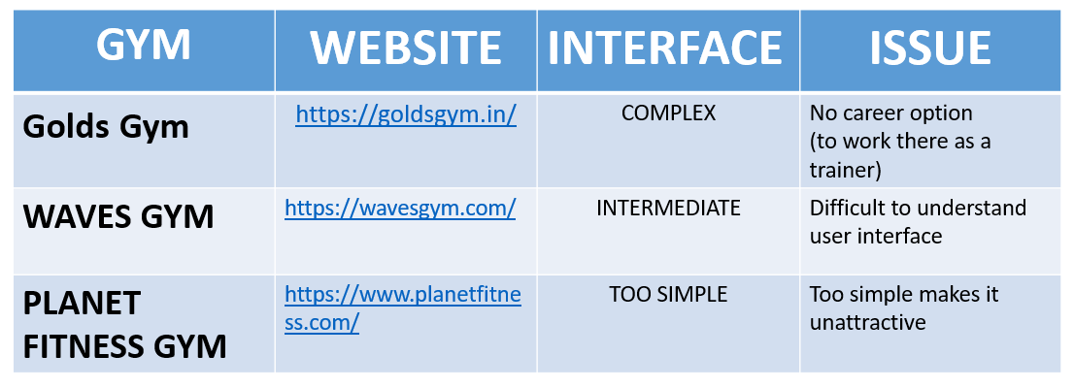

* We collected and studied successfully gym advertisement strategies, locations and their nearby places and in this we did online work and not just manual work.

**Chapter 4**

**Design and Implementation**

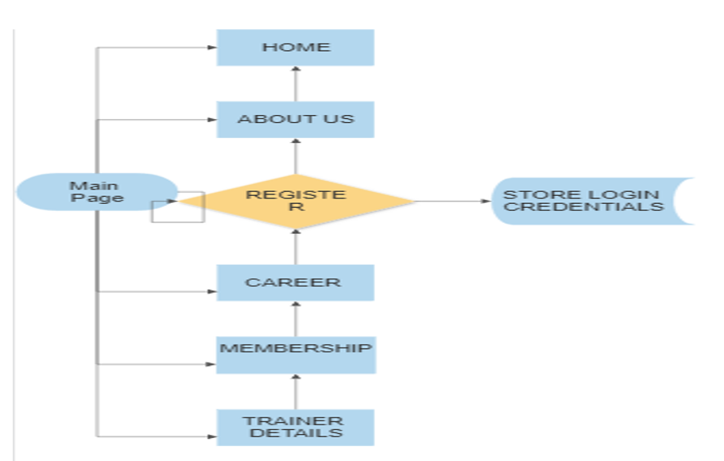

* We have worked in **VScode**, and have kept it simple by using the very basics of **HTML,CSS** and **JS.**

**Chapter 5**

**Results and Discussions**

**

**

**

**

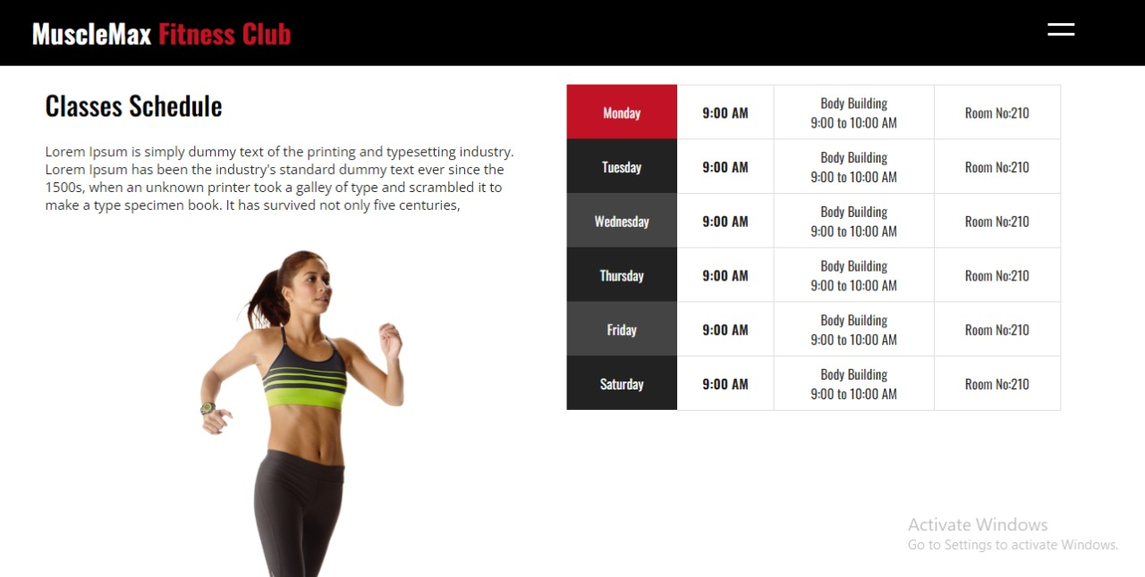

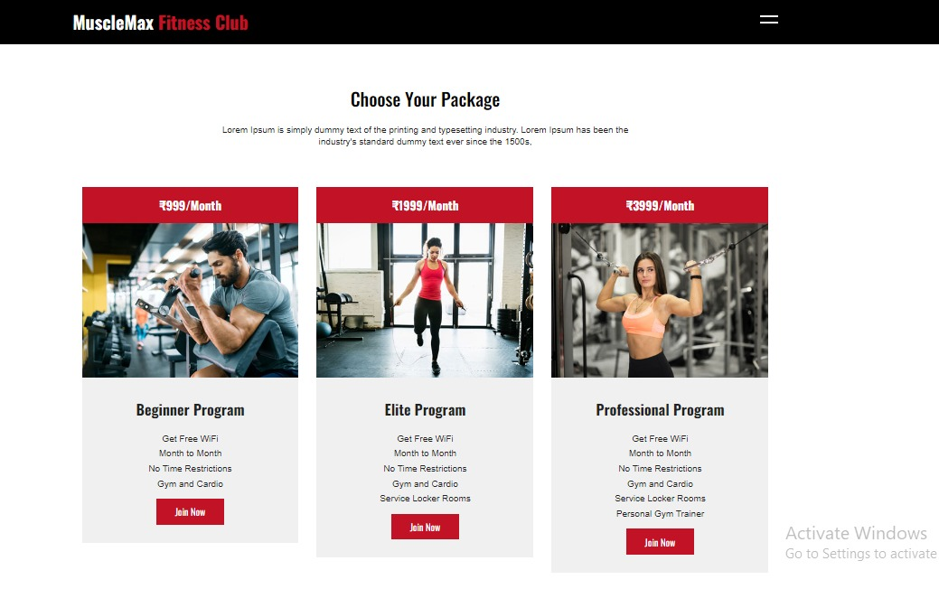

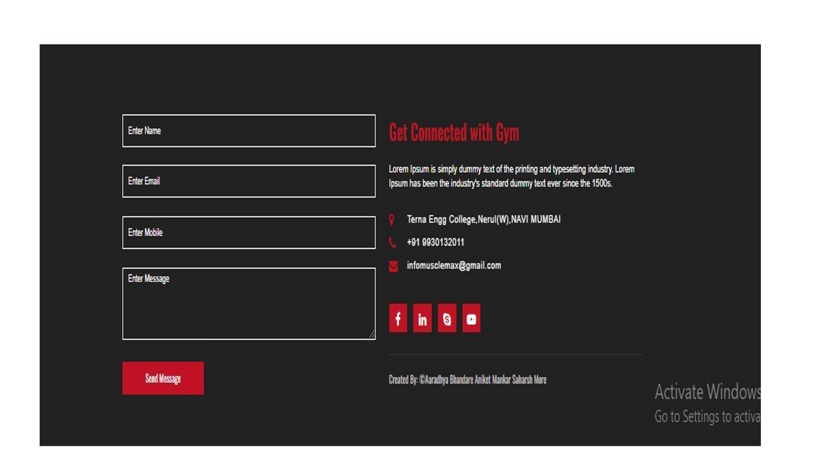

**Chapter 6**

**Conclusion and Future Scope**

* In this way , we are looking at different pros and cons of websites and have collectively made an attempt to create a website without these errors
* With simple user interface ,career opportunity and ease of access , our website will gather the users.
* It may help collecting perfect management in details.
* In a very short time, the collection will be obvious,simple, and sensible.
* It will help person to achieve the importance of a healthier life.

**References**

WWW.YOUTUBE.COM

WWW.CODEWITHHARRY.COM

WWW.GEEKSFGEEKS.COM

WWW.STACKOVERFLOW.COM